SSH PLUGIN

You can use the SSH Plugin to run shell commands on a remote machine via ssh.

USAGE

First go to the global configuration page and add a SSH site.

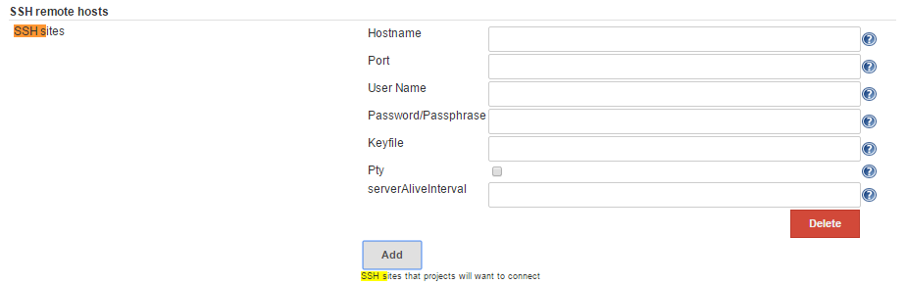

For your job select a configured site and enter the shell commands that should be executetd before and after the build.

